Fundamentally, a binary tree is composed of nodes connected by edges (with further restrictions discussed below). Some binary tree, t, is either empty or consists of a single root element with two distinct binary tree child elements known as the left subtree and the right subtree of t. As the name binary suggests, a node in a binary tree has a maximum of 2 children.

The following diagrams depict two different binary trees:

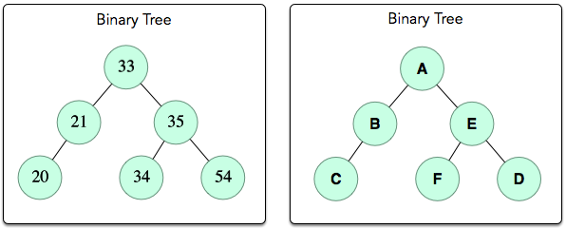

Here are the basic facts and terms to know about binary trees:

1. The convention for binary tree diagrams is that the root is at the top, and the subtrees branch down from it.
2. A node's left and right subtrees are referred to as children, and that node can be referred to as the parent of those subtrees.
3. A non-root node with no children is called a leaf.
4. Some node a is an ancestor of some node b if b is located in a left or right subtree whose root node is a. This means that the root node of binary tree t is the ancestor of all other nodes in the tree.
5. If some node a is an ancestor of some node b, then the path from a to b is the sequence of nodes starting with a, moving down the ancestral chain of children, and ending with b.
6. The depth (or level) of some node a is its distance (i.e., number of edges) from the tree's root node.
7. Simply put, the height of a tree is the number of edges between the root node and its furthest leaf. More technically put, it's $1+max⁡(height\left(leftSubTree\right),height\left(rightSubtree\right))$ (i.e., one more than the maximum of the heights of its left and right subtrees). Any node has a height of 1, and the height of an empty subtree is -1. Because the height of each node is 1+ the maximum height of its subtrees and an empty subtree's height is -1, the height of a single-element tree or leaf node is 0.

Let's apply some of the terms we learned above to the binary tree on the right:

1. The root node is A.
2. The respective left and right children of A are B and E. The left child B of is C. The respective left and right children of E are F and D.
3. Nodes C, F, and D are leaves (i.e., each node is a leaf).
4. The root is the ancestor of all other nodes, B is an ancestor of C, and E is an ancestor of F and D.
5. The path between A and C is A->B->C. The path between A and F is A->E->F. The path between A and D is A->E->D.
6. The depth of root node A is 0. The depth of nodes B and E is 1. The depth of nodes C, F, and D, is 2.
7. The height of the tree, height(t), is 2. We calculate this recursively as $height\left(t\right)=1+(max⁡(height(root.leftChild),height\left(root.rightChild\right))$. Because this is long and complicated when expanded, we'll break it down using an image of a slightly simpler version of t whose height is still 2:  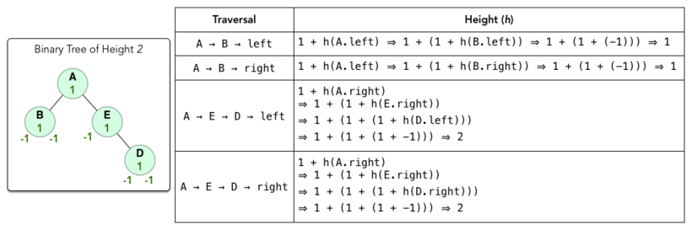 In the diagram above, the height of t is 2 because that is the maximum height of t's left and right subtrees.

Binary Search Tree

A Binary Search Tree (BST), t , is a binary tree that is either empty or satisfies the following three conditions:

1. Each element in the left subtree of t is less than or equal to the root element of (i.e., max(leftTree(t).value <= t.value).
2. Each element in the right subtree of is greater than the root element of (i.e., min(rightTree(t).value > t.value).
3. Both leftTree(t) and rightTree(t) are BSTs.

You can essentially think of it as a regular binary tree where for each node parent having a leftChild and rightChild , leftChild.value <= parent.value <= rightChild.value In the diagram above, the binary tree of integers on the left side is a binary search tree.